Do Tossed Coins Tend to Land on the Side They Started?

Iver Jiang
4.2.2025

Background:

Coin tosses have long been mentioned in statistics when talking about binomial distributions, as it has an expected equal chance (50%) to land on either its head or tail side, and makes for easy example calculations. Interestingly, according to a 2023 paper, there seems to be an inherent human-induced bias when flipping coins by hand, where the average chance of coins landing on the same side it started being around 50.8%. A previous research project, using high-speed cameras that monitored the movements of Humans while tossing coins, also gave a similar estimation of 51%. This experiment aims to replicate the authors’ results ourselves and perhaps explore more relationships between experimental data.

Project Goal:

I am looking for differences between our own experimentation data and the expected population, in order to see if coins tend to land on the side it starts on.

No control group is needed since we have a clear expected value, with the success rate being 0.5. We will perform a sufficient amount of coin tossing in different experiments in order to gather data.

Experimental design:

Prior to the experiment, we must obtain a couple of identical quarter-dollar coins, set up a webcam to film the experiment process, and open up our data collection sheet so we can save our results for later analysis. Such materials have already been prepared and experiment has commenced as of today.

Each day me and my roommate (who has agreed to participate in this experiment) will toss the same coin 200 times minimum (one experiment with 200 trials), and the data of each trial (experiment numbers, trial numbers, starting side, end side, name of the person who tossed the coin, date) will be entered into an excel file and later analyzed with Minitab. Each experiment will be videotaped and archived for verification.
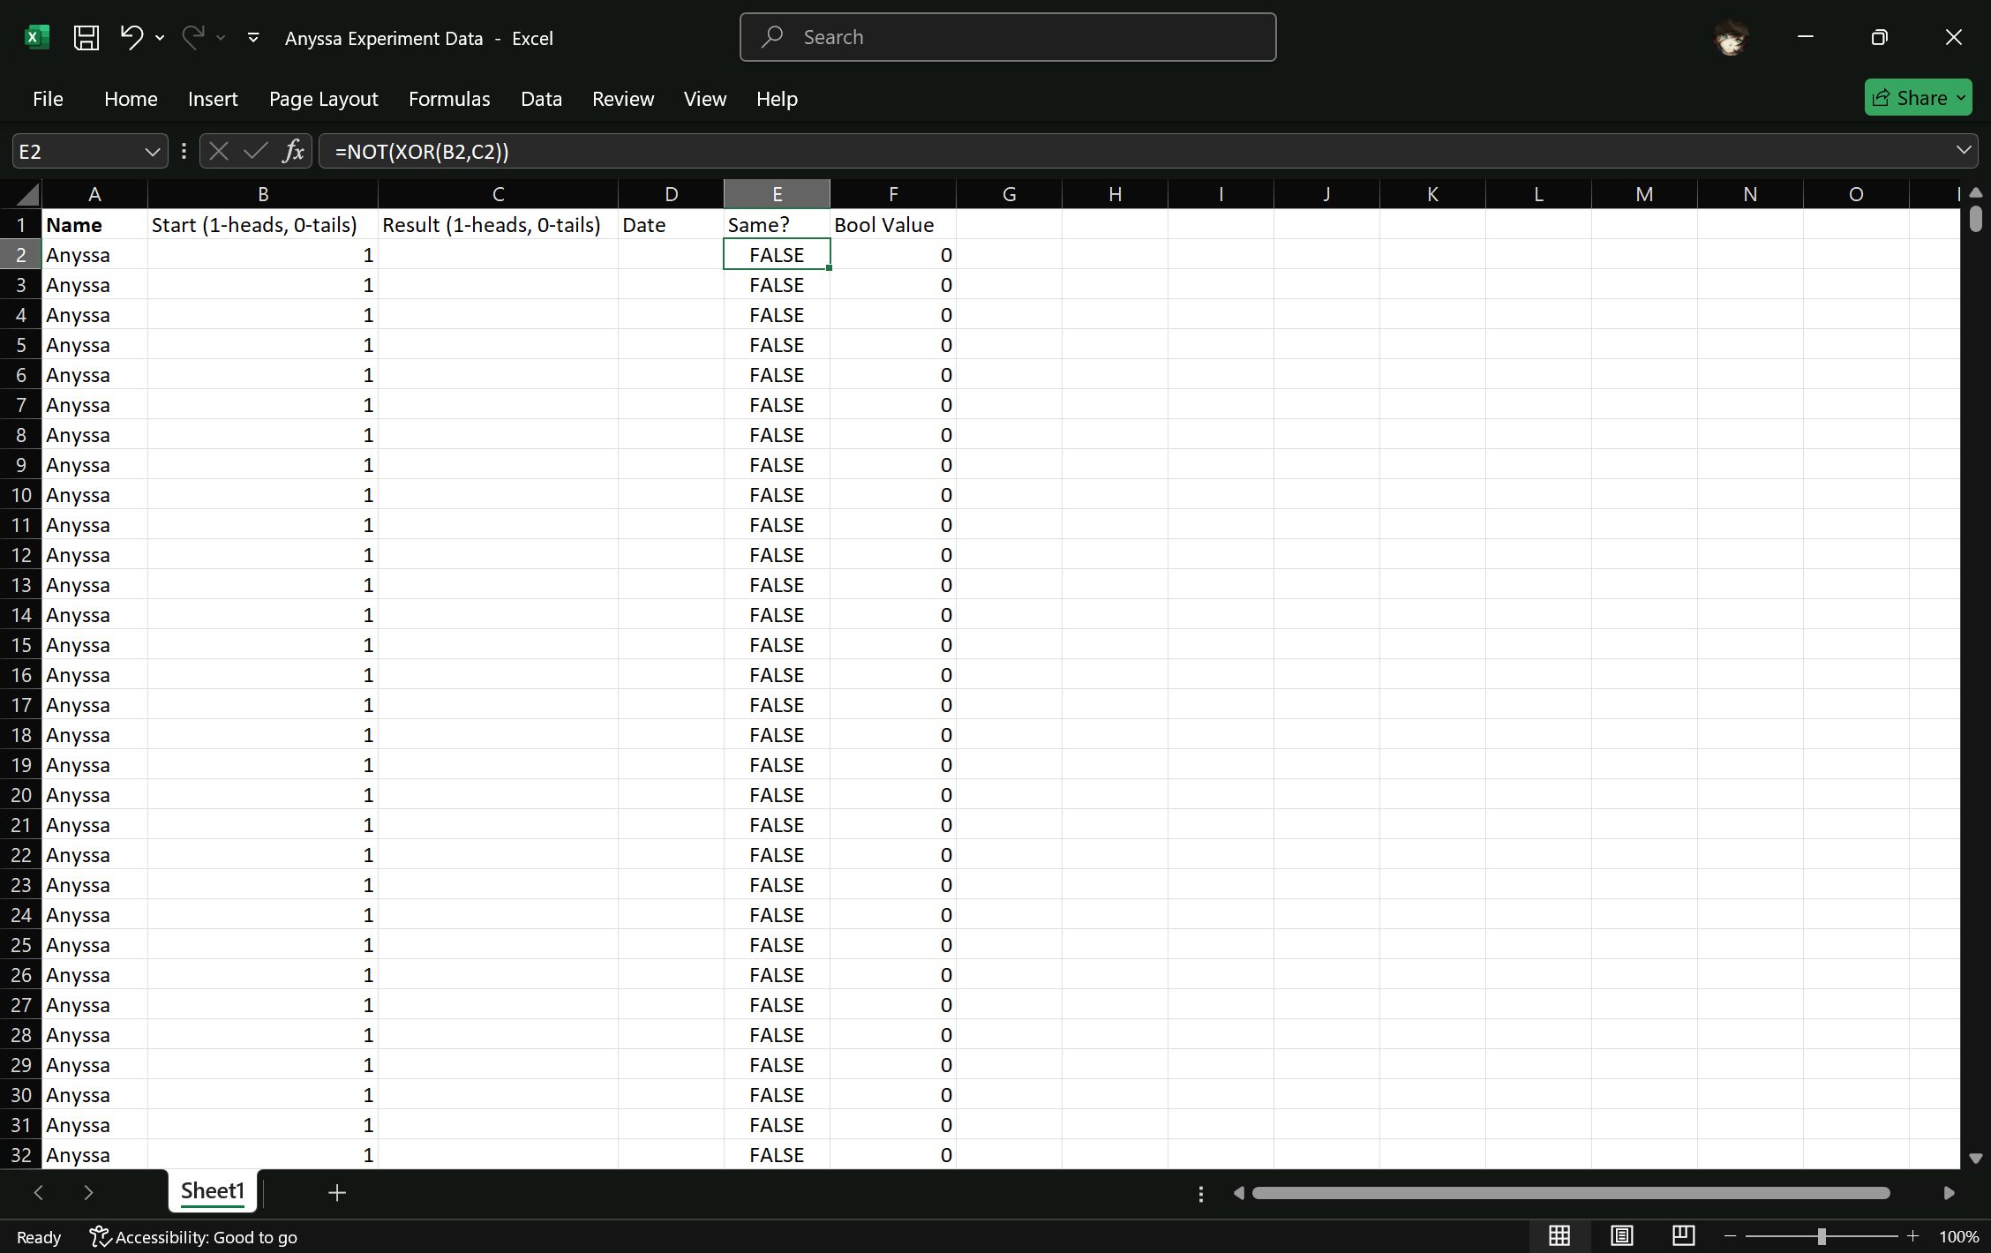
(screenshot of the data entry spreadsheet, with participant name, starting coin side, results, date, and if the starting side is the same as the result (achieved by using an XNOR gate)).

To control for variability, we standardize the coin-flipping method as most commonly defined, shown below: with the coin on the participant’s thumb nail of their dominant hand (in this case both right) and we flip the coin by raising the thumb rapidly, as depicted below.


Coins, by nature due to the presence of their engravings, may not be completely fair, and to eliminate the biases favoring either heads or tails (also known as head-tail bias) we must equally distribute the starting side so it exerts no effect on our final result. Therefore, we alternate between starting with heads and starting with tails in between each experiment (Experiment 1 will all start with heads up, experiment 2 will all start with tails up, etc.) in order to achieve a 50/50 ratio of heads-up start and tails-up start.

This should, by the lab due-date, yield a minimum sample size of 60 experiment and 12,000 trials. This will allow us to find the sample standard deviation per central limit theorem. Ideally, I would be able to calculate a 95% confidence interval around the sample mean probability of the coin landing on the same side. (with 0.500 being a 50% chance).

To answer our question, we will do a two-tailed hypothesis test comparing our sample mean (and total mean) to the expected value of 0.5, and determine a p-value that will reject or fail to reject the null hypothesis. A separate two-tailed hypothesis test will also be done comparing the results between our two participants, in an effort to determine if the bias, if it does exist, differ among individual participants due to the different ways people toss coins.

To minimize the time spent on data entry, I plan to set up a macro on my local instance of Microsoft Excel which allows me to quickly record the results. I expect each 200-coin experiment to not take more than 20 minutes (1200 seconds) each time.

I expect the entire experiment to cost nothing, since we would be able to get dollar coins from the bank for free. I also need to at least borrow the video-camera used to videotape the experiment itself. I will be able to provide video storage myself. The barriers, if they do exist, will probably mostly relate to our laziness in doing the experiments ourselves.

Statistical method:

I plan to conduct a hypothesis test by conducting multiple Bernoulli experiments with a sample size of 200 per experiment. We can then calculate the variation, standard deviation and use the Binomial test to estimate our p value in order to test the hypothesis. We will also be able to calculate a 95% sample confidence interval (i.e. if we toss a coin 200 times, the true mean probability will fall in this range 95% of the time) by using a two-sample proportion Z-test (formula attached below) to compare the difference in our experimental probability and expect probability of 0.5.
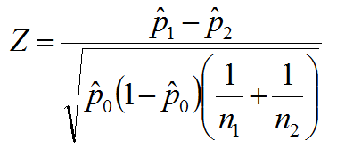

We also plan to summarize the proportions of success in each experiment as a data point, and use Logistical Regression in order to determine the extent each participant differ from each other. (The formula for pi – the probability of success in each experiment is defined below)

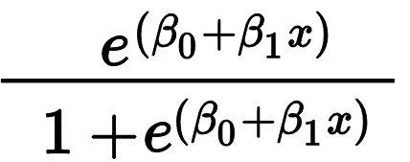
To answer our question, we establish the null hypothesis as “The probability of a coin landing on the side it started on is 50%”, and the alternative hypothesis “The probability of a coin landing on the side it started on is not equal to 50%”. By comparing the toss statistic between the two participants (once again, using a two-sample Z-test), we can also try to see if the results differ between different individuals.

Bibliography:

- František Bartoš et al. Fair Coins Tend to Land on the Same Side They Started: Evidence from 350,757 Flips. https://arxiv.org/abs/2310.04153, 2023
- Persi Diaconis et al. Dynamic Bias in the Coin Toss. https://www.stat.berkeley.edu/~aldous/157/Papers/diaconis_coinbias.pdf, 2007

See Bartos et al. Page 2 (2023), found at https://arxiv.org/abs/2310.04153.
Diaconis et al. Page 219 (2007), Dynamical Bias in the Coin Toss, found at https://www.stat.berkeley.edu/~aldous/157/Papers/diaconis_coinbias.pdf
(Source: https://commons.wikimedia.org/wiki/File:Coin_Toss_(3635981474).jpg)

